A refugee who conquered the world

The Destruction of Smyrna or the Great Fire of Smyrna refers to the events of the massacre of the Greek and Armenian population of Smyrna by the Kemalist army, as well as the burning of the city. The last one lasted from August 31 to September 4 (with the old calendar) of 1922.

On September 9, Smyrna fell into the hands of Kemal. From that day on, those Greeks who did not manage to leave had their own cross to carry. Among them is one of the most famous Greeks of the 20th century, Aristotle Onassis. With his father Socrates held in prison in the Turkish quarter of Smyrna, his beloved uncle Alexander hanged at Kasamba, 18-year-old Aristotle remained at the family villa in Karatas. The Turks had commandeered the house and Aristotle continued to live there because he had convinced the uninvited occupants that he was the only one who could fix the quirky heating system and plumbing, and through his father's business contacts he had access to state-of-the-art gramophone drums , as in the best cigars and whiskeys. It was all a big, clever lie that bought him time, as well as a valuable military pass that allowed him to visit his father and the burnt down headquarters of the family business. Socrates Onassis believed that there the heavy metal safes with the many Turkish banknotes might have been saved from the fiery blaze. And he was right.

Little Aristotle stuffed as many bills as he could into his jacket, shirt and trousers. Thanks to these, his father was freed and organized his own escape with the American ship "Endsal".

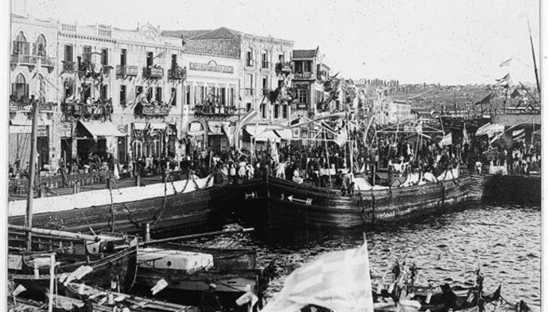
https://www.kathimerini.gr/life/people/819867/o-aristotelis-onasis-stin-kolasi-tis-flegomenis-smyrnis/
His business career
He began his business career by setting up an import-export company and making a fortune importing Turkish tobacco to Argentina. He acquired Argentine citizenship in 1929.[16][17] He eventually established his first shipping trading company in Buenos Aires.
Onassis created a fleet of trucks and tankers that eventually exceeded 140 ships. Most of the fleet usually operated under flags of convenience where laws and regulations are more relaxed than those of the owners' country(The high profitability of Onassis' fleet has been largely attributed to his disregard for the standards that normally govern international shipping).
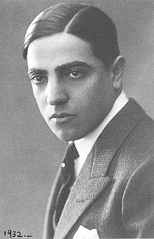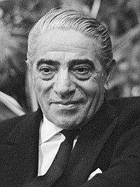
Between 1950 and 1956, Onassis began successfully whaling off the west coast of South America. His first shipment netted $4.5 million. In 1956, Aristotle Onassis bought from the Greek State the privilege of operating Hellenic Airlines and founded OlympicAviation.https://el.wikipedia.org/wiki/%CE%91%CF%81%CE%B9%CF%83%CF%84%CE%BF%CF%84%CE%AD%CE%BB%CE%B7%CF%82_%CE%A9%CE%BD%CE%AC%CF%83%CE%B7%CF%82
It is admirable that a refugee who started from zero, managed to build such an empire with millions of annual revenues

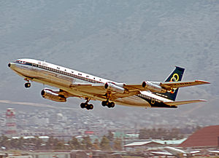
An Olympic Airlines Boeing 707, 1973
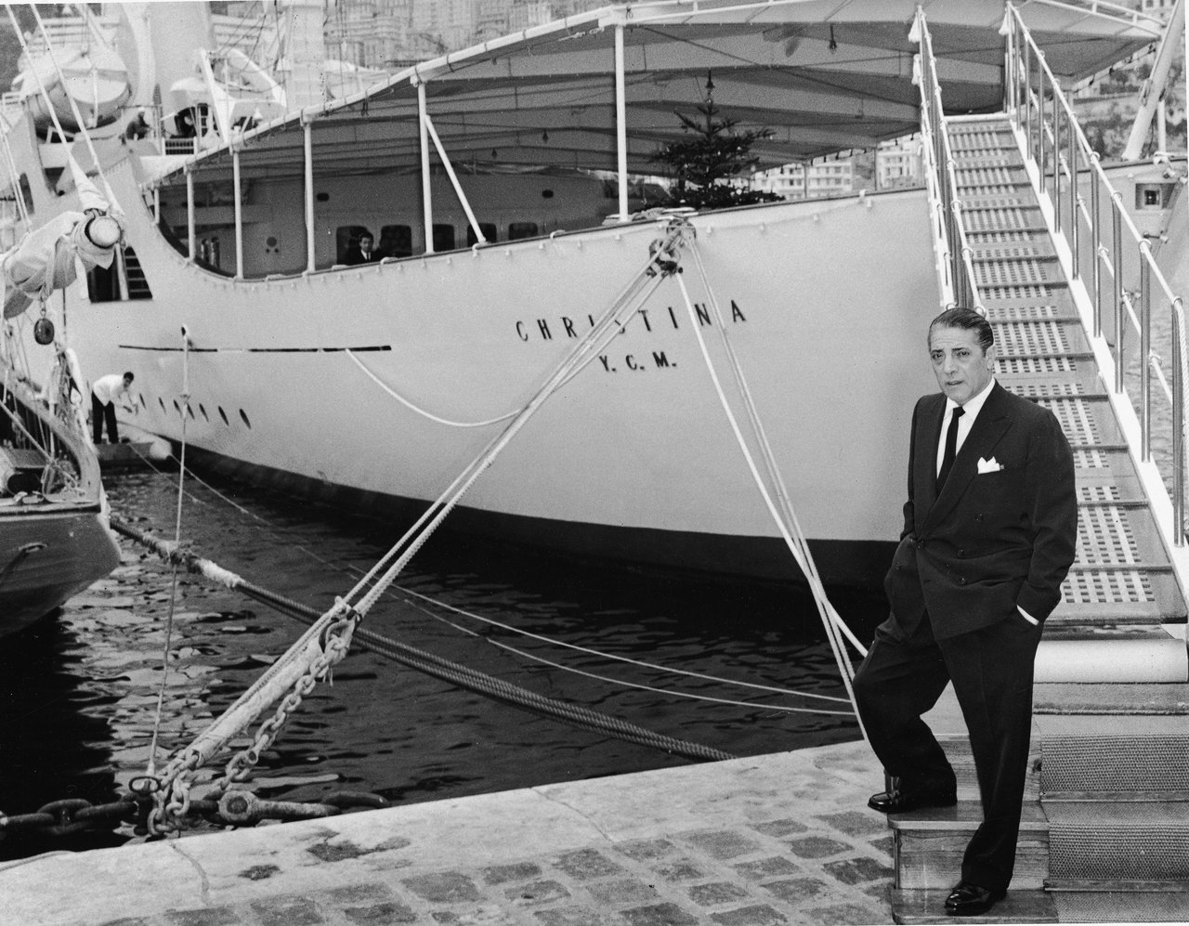
outside the yacht of Aristotle Onassis

