SPRING
𝓼pring, also known as springtime, is one of the four temperate seasons, succeeding winter and preceding summer. There are various technical definitions of spring, but local usage of the term varies according to local climate, cultures and customs. When it is spring in the Northern Hemisphere, it is autumn in the Southern Hemisphere and vice versa. At the spring (or vernal) equinox, days and nights are approximately twelve hours long, with daytime length increasing and nighttime length decreasing as the season progresses until the Summer Solstice in June (Northern Hemisphere) and December (Southern Hemisphere).
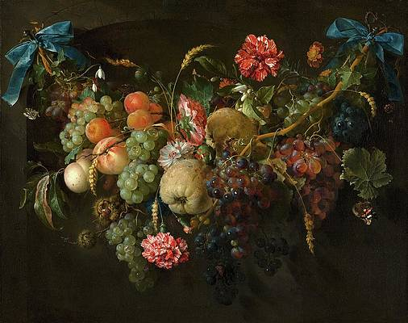
Spring and "springtime" refer to the season, and also to ideas of rebirth, rejuvenation, renewal, resurrection and regrowth. Subtropical and tropical areas have climates better described in terms of other seasons, e.g. dry or wet, monsoonal or cyclonic. Cultures may have local names for seasons which have little equivalence to the terms originating in Europe.

𝐼n the ancient world, the coming of spring was often linked to mythical tales of rebirth and resurrection. At the centre of these stories were a cast of fertility gods who share similar origin stories, and parallels with the Christian festival of Easter.
Springtime is celebrated with a diverse array of traditions across the world. Christians associate the season with Easter when they celebrate the resurrection of Jesus Christ. But the idea of a deity who perishes and is brought back to life was a common theme in the ancient world, predating the Bible. Spring mythology is often intertwined with the Earth’s cycle, meaning the stories feature fertility gods as the focal point.

The connection between rebirth, resurrection and spring can be tracked as far back as ancient Egypt and the god Osiris. Osiris was murdered by his rival Seth, who tore his body to pieces and scattered the parts across Egypt. The goddess Isis retrieved the pieces and buried them – an act that brought Osiris back to life to sit as judge in the underworld. His demise and rebirth speak to his dual role as the fertility god who gave life to plants and vegetation while controlling natural phenomena such as the annual flooding of the Nile. 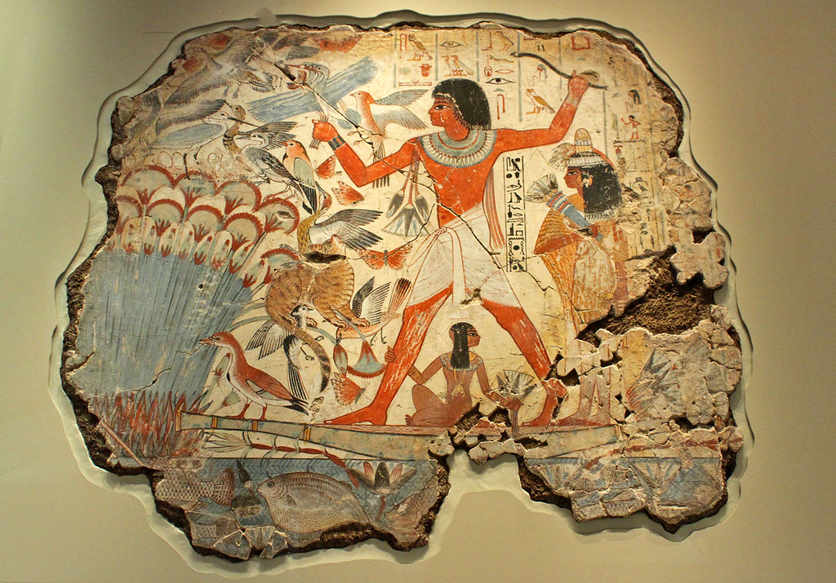

During the pre-Christian period of the Roman Empire, people worshipped Cybele. The Cybele religion emerged from the area that is now Turkey and found its way to the heart of the empire with its deities absorbed into the Roman pantheon. Cybele’s companion was the god of fertility, Attis, who, as the legend goes, was sent mad and castrated himself under a pine tree just before his wedding. (These things happen.) Attis was subsequently resurrected and represents the crops and fruits that die off in winter and return in spring. The centrepiece of the Cybele Festival was a pine tree decorated with violets – the flowers that purportedly grew from the blood of Attis.

In ancient Sumer, modern-day southern Iraq, the goddess of fertility, love, war and sex was Inanna (also known as Ishtar). Following a doomed attempt to wrest control of the underworld from her sister, Inanna was killed and transformed into a piece of meat. When she was resurrected, she designated her capricious young lover to take her place in the underworld. The vague semblance between the words Ishtar and Easter has led to the former’s being supposed, most likely incorrectly, to have informed the Easter myth.

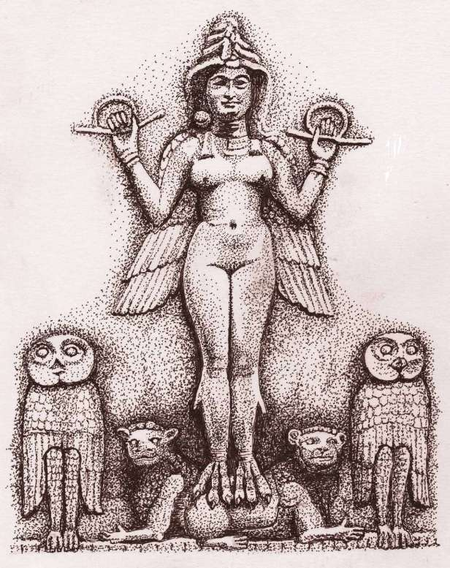

More plausible, but by no means definitive, is the idea that Easter is connected to the Anglo-Saxon goddess of spring and fertility and that the name is derived from hers, Eostre. The main source for this, however, is the Dark Age chronicler Bede the Venerable. Supposedly, Eostre was symbolised by a hare, but it wasn’t until the 17th century in Protestant Europe that the floppy-eared animal became embedded in the Easter tradition. Eggs, on the other hand, have featured in the celebration since around the 13th century. Eggs were forbidden by the church to be consumed during Holy Week, so any laid during that period were deemed holy. The egg became a symbol of Jesus’s resurrection, but the son of god has become a forgotten figure in his own story with the conflation of these two elements. Today, children gleefully celebrate the annual coming of a bunny rabbit that, in flagrant disregard of the laws of nature, lays chocolate eggs for them to discover and consume.
To celebrate the arrival of spring, Culture Trip explores themes of revolution, rebirth and renewal across the world.
PERSEPHONE was the goddess queen of the underworld, wife of the god Haides (Hades). She was also the goddess of spring growth, who was worshipped alongside her mother Demeter in the Eleusinian Mysteries. This agricultural-based cult promised its initiates passage to a blessed afterlife.

PERSEPHONE was the goddess queen of the underworld, wife of the god Haides (Hades). She was also the goddess of spring growth, who was worshipped alongside her mother Demeter in the Eleusinian Mysteries. This agricultural-based cult promised its initiates passage to a blessed afterlife.

Persephone was titled Kore (Core) (the Maiden) as the goddess of spring's bounty. Once upon a time when she was playing in a flowery meadow with her Nymph companions, Kore was seized by Haides and carried off to the underworld as his bride. Her mother Demeter despaired at her dissappearance and searched for her the throughout the world accompanied by the goddess Hekate (Hecate) bearing torches. When she learned that Zeus had conspired in her daughter's abduction she was furious, and refused to let the earth fruit until Persephone was returned. Zeus consented, but because the girl had 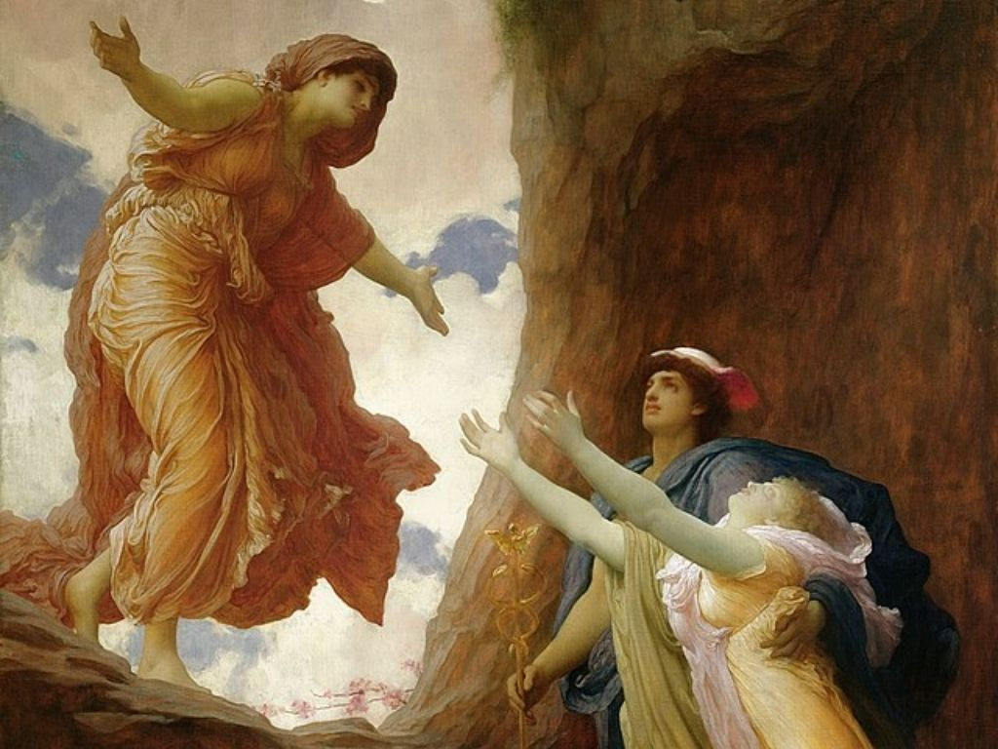
tasted of the food of Haides--a handful of pomegranate seeds--she was forced to forever spend a part of the year with her husband in the underworld. Her annual return to the earth in spring was marked by the flowering of the meadows and the sudden growth of the new grain. Her return to the underworld in winter, conversely, saw the dying down of plants and the halting of growth.

In other myths, Persephone appears exclusively as the queen of the underworld, receiving the likes of Herakles and Orpheus at her court.

Persephone was usually depicted as a young goddess holding sheafs of grain and a flaming torch. Sometimes she was shown in the company of her mother Demeter, and the hero Triptolemos, the teacher of agriculture. At other times she appears enthroned beside Haides.

𝐼 t's steeped in love and joy - the essence of all that is good - and is associated with ideas of rebirth, renewal, resurrection and regrowth. Spring symbolizes life in all its glory.
Primavera, is a large panel painting in tempera paint by the Italian Renaissance painter Sandro Botticelli made in the late 1470s or early 1480s .It has been described as "one of the most written about, and most controversial paintings in the world",and also "one of the most popular paintings in Western art".

The painting depicts a group of figures from classical mythology in a garden, but no story has been found that brings this particular group together. Most critics agree that the painting is an allegory based on the lush growth of Spring, but accounts of any precise meaning vary, though many involve the Renaissance Neoplatonism which then fascinated intellectual circles in Florence. The subject was first described as Primavera by the art historian Giorgio Vasari who saw it at Villa Castello, just outside Florence, by 1550.

Although the two are now known not to be a pair, the painting is inevitably discussed with Botticelli's other very large mythological painting, The Birth of Venus, also in the Uffizi. They are among the most famous paintings in the world, and icons of the Italian Renaissance; of the two, the Birth is even better known than the Primavera. As depictions of subjects from classical mythology on a very large scale, they were virtually unprecedented in Western art since classical antiquity.

The history of the painting is not certainly known; it may have been commissioned by one of the Medici family, but the certainty of its commission is unknown. It draws from a number of classical and Renaissance literary sources, including the works of the Ancient Roman poet Ovid and, less certainly, Lucretius, and may also allude to a poem by Poliziano, the Medici house poet who may have helped Botticelli devise the composition. Since 1919 the painting has been part of the collection of the Uffizi Gallery in Florence, Italy. 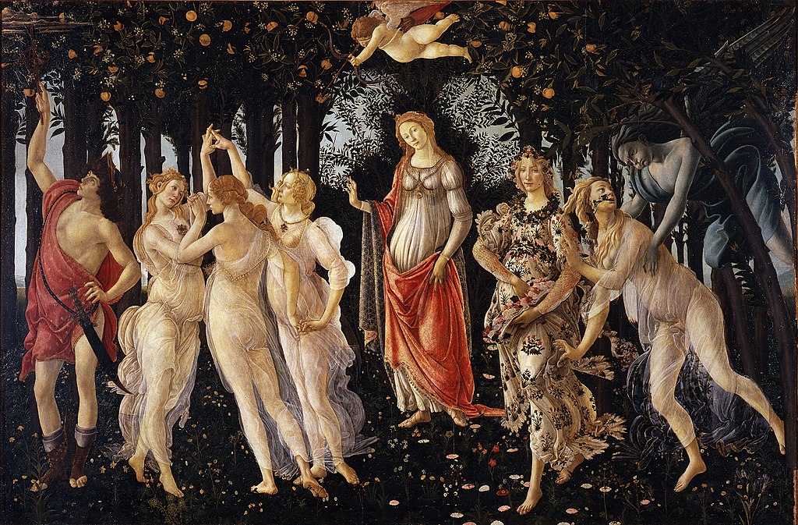

Spring is an 1894 oil-on-canvas painting by the Anglo-Dutch artist Lawrence Alma-Tadema, which has been in the collection of the J. Paul Getty Museum in Los Angeles, California, since 1972. The painting relates the Victorian custom of children collecting flowers on May Day back to an Ancient Roman spring festival, perhaps Cerealia or Floralia or Ambarvalia, although the details depicted in the painting do not correspond to any single Roman festival. It was the inspiration for the scene of Julius Caesar's triumphal entry into Rome in the 1934 film Cleopatra. 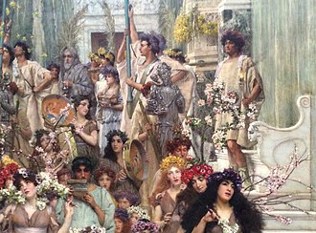
- https://en.wikipedia.org/wiki/Spring_(season)
- https://www.google.com/url?sa=i&url=https%3A%2F%2Ffineartamerica.com%2Fart%2Fpaintings%2Fskinner&psig=AOvVaw1VzsVhri5kScTlCufUtIcA&ust=1683274835915000&source=images&cd=vfe&ved=0CA4QjRxqFwoTCPC6_sad2_4CFQAAAAAdAAAAABAD
- https://theculturetrip.com/europe/united-kingdom/articles/rebirth-and-resurrection-spring-myths-of-the-ancient-world/
- https://www.google.com/url?sa=i&url=https%3A%2F%2Fwww.flickr.com%2Fphotos%2Fsnarfel%2F8141217318&psig=AOvVaw3VIVrLjweptt8lavhr-nmc&ust=1683272160514000&source=images&cd=vfe&ved=0CA4QjRxqFwoTCMCjm56b2_4CFQAAAAAdAAAAABAD
- https://www.google.com/url?sa=i&url=https%3A%2F%2Fcarljungdepthpsychologysite.blog%2F2020%2F07%2F17%2Fjoseph-campbell-the-sumerian-myth-of-the-goddess-inannas-descent-to-the-nether-world-2%2F&psig=AOvVaw1Bs4HtgqgIdp8j_nsKErd7&ust=1683274982552000&source=images&cd=vfe&ved=0CA4QjRxqFwoTCJj8_oye2_4CFQAAAAAdAAAAABAD
- https://www.theoi.com/Khthonios/Persephone.html
- https://www.google.com/url?sa=i&url=https%3A%2F%2Fwww.definitelygreece.com%2Fthe-story-of-persephone-and-hades%2F&psig=AOvVaw1FXC0MP_WcnBGhs2RQftL9&ust=1683273129066000&source=images&cd=vfe&ved=0CA4QjRxqFwoTCMDez6CX2_4CFQAAAAAdAAAAABAE
- https://en.wikipedia.org/wiki/Primavera_(Botticelli)
- https://en.wikipedia.org/wiki/Spring_(painting)

